Practice with aaBridge or on BBO (with the 1827 hands)
Written by Roger Pfister http://RogerPf.com/aaBridge
aaBridge contains a separate 'dealer' application, that can generate .PBN files but that is NOT what this document is about.
This document is about using the over 1827 deals in some 40 .PBN files that have already been generated for you. All are available for easy use on aaBridge or for upload to BBO.
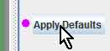
It is always a good idea to click the Apply Defaults button. It has a distinctive pink dot. This way you clear any previous settings.

Finding the Sets of Hands in aaBridge
Please follow along with THIS example.
From the aaBridge menubar select
Books-L > 1827 Hands for upload to BBO or Practice on aaBridge
(this is the final item in the menu)
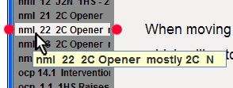
Click on the following name
nml 22 2C Opener

it is roughly in the middle – hover over it to see the full name – see image (red dots).
That name will also show in the main aaBridge window with additional underscores.
nml_22_2C_Opener__mostly_2C__N.txt

(The __N near the end is a reminder that North is the "Hot Seat" for these hands and that is the seat you will be shown first as you view them in aaBridge.)

You can see from the Navbar at the bottom of the aaBridge window that this set of hands contains 40 deals, some others contain 64).

Getting a set of Hands for BBO
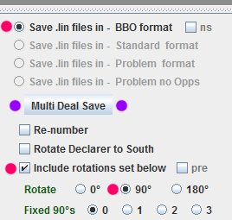
Raise the bottom divider and select the settings as shown on the right (red dots).
These are
● Save lin files in – BBO format
● Include rotations set below
● Rotate 90°

Click the Multi Deal Save button (purple dots).
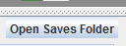
Click on the Open Saves Folder button, on the left just below the divider.

The newly created lin file will be in that folder - look for:
nml__22__2C_Opener__mostly_2C__N___--__90_rotation.lin
(If you are starting with your own lin, or pbn ie: a file that is outside aaBridge then the place to look for the newly created file is next to your original file but see Force Multi Save into Saves folder option.)
The 90° rotation in the name is a reminder that each deal is turned 90° from the one before.
So this is an ideal set of hands for four people to bid and play on BBO.
If instead you select 180° rotation you will have an ideal set for a BBO Partnership Practice table.
Don't let the fact that some sets were created to test a particular bidding system (Precision) stop you from using them. The same hands are just as likely to come up when you're playing a different system -- for example, 2 Over 1.
To upload the hands to BBO see the Doc Collection document
Save 'n' Send to BBO - Lin file upload.doc
<End of Topic - Practice on BBO>

Self Practice on aaBridge
Go back to the 1827 hands inside aaBridge, as on page 1. In this example the chosen set is
nml__01__1N_15-17__LEB__LHO_intervenes
(The images shown here will not match the set of images you can see for this set name because new hands for all the files are frequently re-generated for each new release).
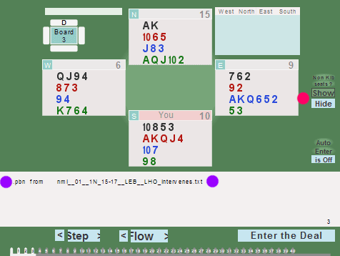
Click the Flow button, or better still, use your mouse wheel to move to the First deal.
Here you can see the file name of the script file that was used to generate the hands. (two purple dots.)
At the very bottom of the image on the right is a line of numbers. These show 40 deals and we are currently viewing the first deal.
The Show / Hide buttons (red dot) will Show / Hide the non Kib seats.

As you click Flow (or use your mouse wheel) you rapidly scan through all the deals. One issue is that it takes a lot of clicks to get to the Analyse and Shuf Op buttons for each deal.
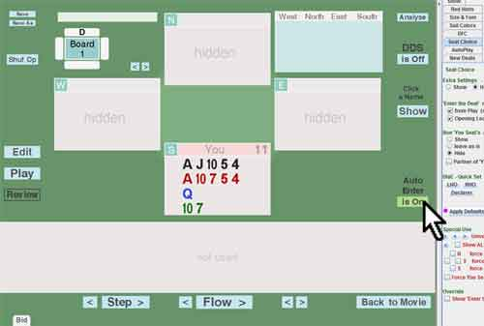
The best way around this is -

Auto Enter
On the right hand side, in the green area is the Auto Enter button.
Click the Auto Enter button to turn the feature on.
When you now click Flow or use your mouse wheel to go forwards and backwards then the first page that we saw above will now look as shown on the right. With only one hand visible.
If you click the Edit, or any other button you will come out of 'Auto Enter' mode.
If this happens, then later – switch Auto Enter back on (assuming you want it on).

Self Practice - (a) Bidding
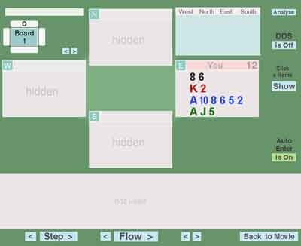
This example (LEB) is about as hard as it gets, and it is still simple.
You can see the South hand (the hot seat hand) you know that North will always be opening 1NT and tell yourself (loudly) that partner has opened 1NT.
Next you need to click on East's name zone, where is now says 'You' in a pink box.
This will reveal the East hand and you can now choose East’s Intervention bid. In this case you have a choice between a natural 2 Diamond long single suit and a DONT style double showing a single suit of unspecified denomination.
Click on South's name zone and decide your best response (as defined by the bidding system you are trying to learn).
When you have decided your bid and "said it to yourself" then you can ...
Click on North's name zone and decide what North's response would be to your bid. (Here West will always pass.)
When the bidding is complete you can (if you wish) reveal all the hands by the Show in the green area on the far right.
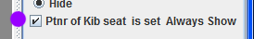
To see both the North and South hands as you bid then Check the "Ptnr of Kib ..." button (purple dot).

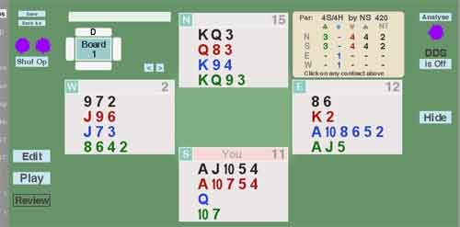
Analyse and Shuf Op
To get an idea of how often the contract you bid will make, do the following:
Click Analyse (one dot) and you can see all the makeable contracts.
Click Shuf Op (two dots) and the Opps hands will be shuffled and the Analyser will again show you how well you can expect to do on the new layout.
After a few clicks of Shuf Op you will start to get feel for how often it makes and how often it does not.
(Yes, I do know this is not particularly applicable in this case, as there is intervention bidding.)
<continued on next page>

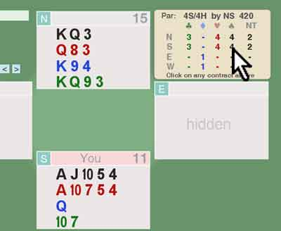
Self Practice - (b) Play
Should you want to play the hand and not just bid it
Click on the Analyse button
then select from the Analyser box the contract (for SOUTH) you want to play in and click it.
Four Spades is in process of being selected in the image on the right.

As you select the contract aaBridge will
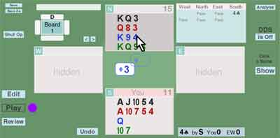
automatically go into Play mode (purple dot) and West will play a card.
You will now need to play a card from dummy, here the 4 of Diamonds.

You can now play the hand against the aaBridge bots in the normal way.

The Playing a Hand.doc from the doc collection is a good place to start.

In Addition - the Deal and Merge Package
You can generate your own new sets of 1827 hands whenever you want using the aadm_package from the document collection.
Read the doc
Deal and Merge - What it will do for You.doc

< end of document >

